Session stickiness lab----------🡪

Please implement the following diagram

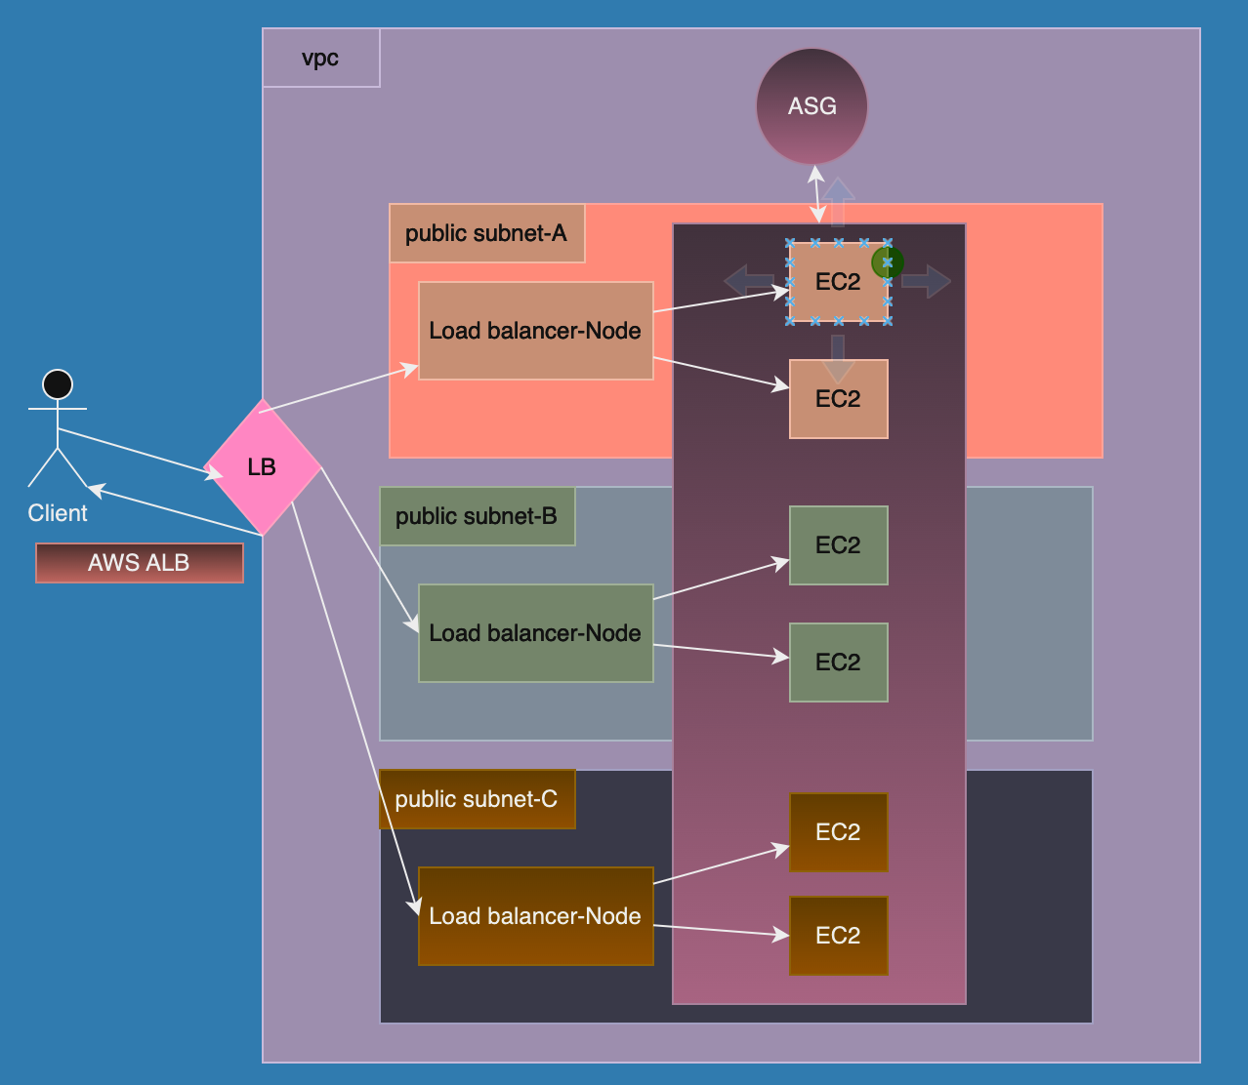

1. Login to AWS Console management
2. Create vpc that has 3 nodes && internet Gateway

1. Create 3 public subnets on this vpcA screenshot of a computer

   Description automatically generated
2. Create internet gateway && attach to vpc



1. Edit route table

1. Create instance that has apache && index.html has instance id && AZ



Select instance -----🡪 Actions -----🡪 Image && template ---🡪 Create template

from instance.

1. Create ASG

